🎓 DIGITAL SCHOOL & COLLEGE MANAGEMENT PORTAL

Web & Mobile E-Learning Solution Proposal +263788307612

1. Executive Summary
In today’s digital era, educational institutions require more than classrooms and textbooks. They need efficient, modern, and connected systems that enhance learning, administration, and communication.
We offer a complete Web & Mobile School/College Management System designed to modernize academic institutions by bringing students, teachers, administrators, and parents into one secure digital platform.
This solution improves:
- Academic performance tracking
- Communication & transparency
- Operational efficiency
- Institutional branding & competitiveness
- Fees Management
The platform is fully customizable for schools, colleges, academies, and universities, and works on desktop, tablet, and mobile devices.

2. What We Are Offering
A fully-featured e-Learning & School Management Portal delivered as:
✅ Web Application (accessible via browser)
✅ Mobile App (Android-ready & installable without Play Store if needed)
✅ Custom-branded for each institution
One system. One login. Total control.

3. Target Institutions
This system is ideal for:
- High Schools (Forms 1–6)
- Colleges & Polytechnics
- Universities
- Private Academies
- Vocational & Technical Institutes
- Training Centers

4. System Overview (How It Works)
The platform is divided into three major portals:

🎓 Student Portal

👨‍🏫 Teacher Portal

👨‍💼 Administrator Portal
Each user logs in and sees only what is relevant to them.

5. Key Features (Explained Simply)

🎓 Student Portal
Students can:
- View personal profile & academic information
- Access grades and performance analytics
- Check assignments & deadlines
- View timetables and schedules
- Access digital library resources
- View notices & announcements
- Check school fees & payment history
Benefit:
Students stay informed, organized, and motivated.

👨‍🏫 Teacher Portal
Teachers can:
- Manage assigned classes
- Upload assignments & resources
- Enter and manage grades
- Track attendance
- Generate academic reports
- Communicate announcements
Benefit:
Teachers save time and focus more on teaching.

👨‍💼 Admin Portal
Administrators can:
- Manage students, teachers, and classes
- Control school fees & payments
- Publish notices and announcements
- Manage library resources
- Generate institutional reports
- Monitor system activity
Benefit:
Centralized control, reduced paperwork, improved accountability.

6. Sample Screens (Mockup Preview Description)
These visuals are provided as sample demonstrations of the final product.

🔐 Login & Registration Screen
- Clean, modern interface
- Role-based login (Student / Teacher / Admin)
- School branding (logo & colors)
📷 Sample Image:
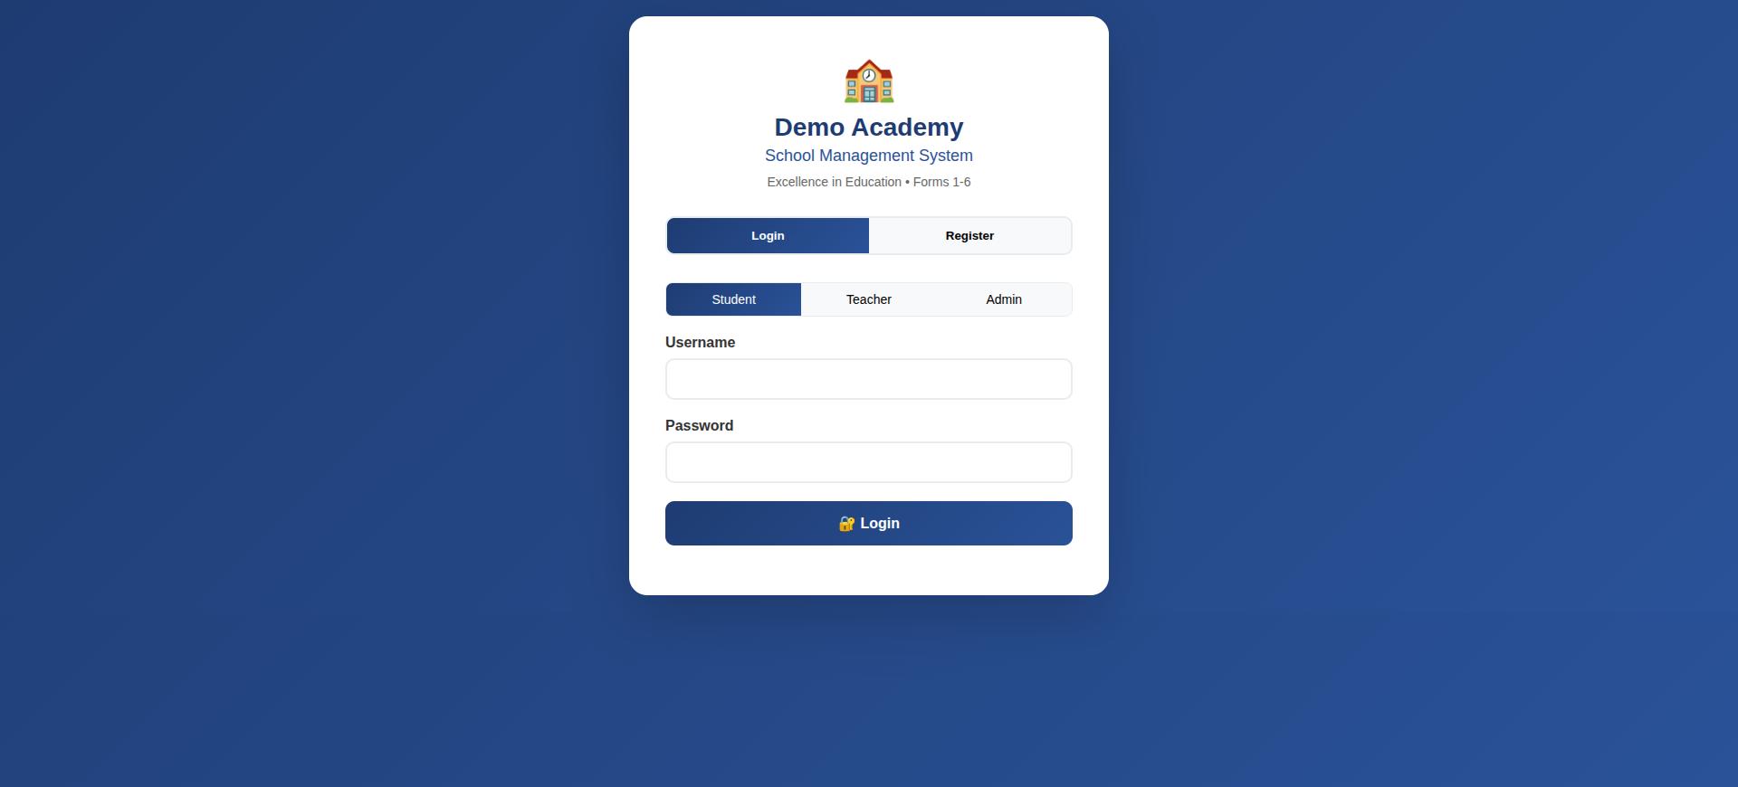

🎓 Student Dashboard
- Performance overview
- Subjects, grades & progress
- Daily schedule & announcements
📷 Sample Image:
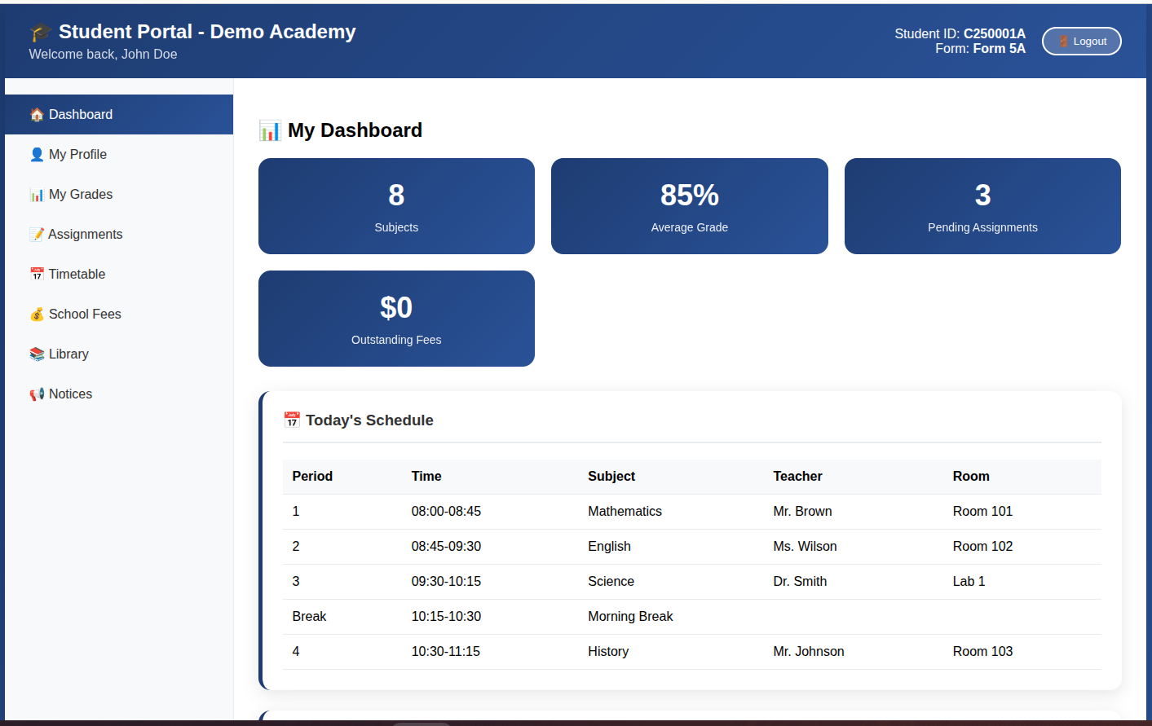

👨‍🏫 Teacher Dashboard
- Classes taught
- Student performance insights
- Assignment management tools
📷 Sample Image:
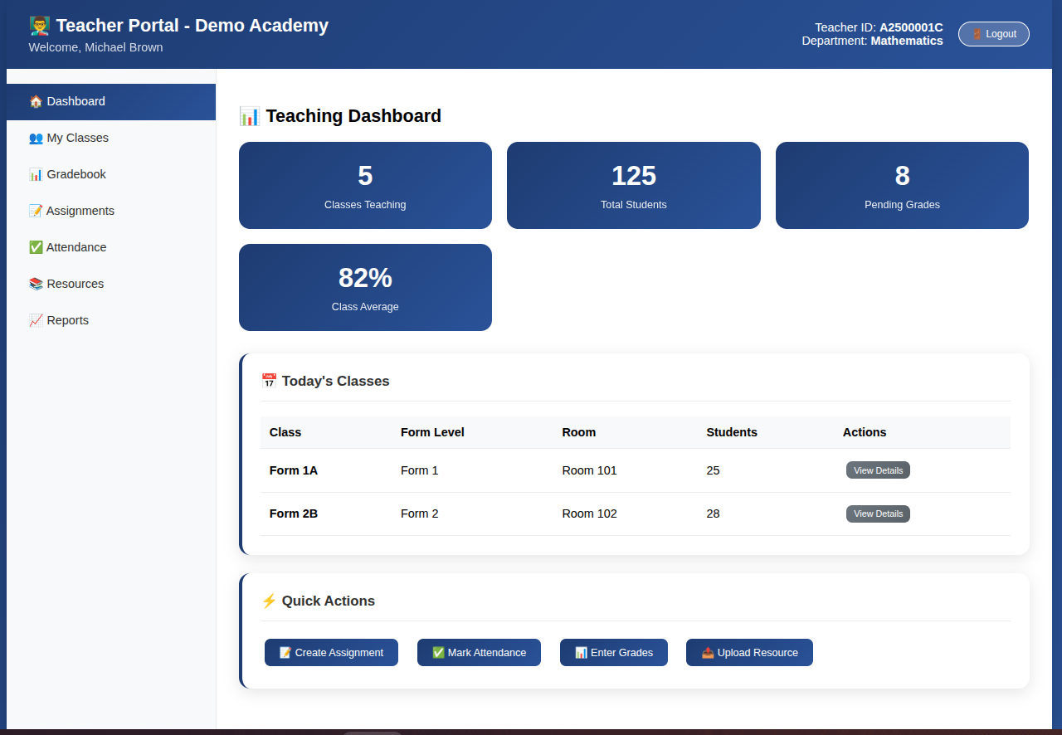

👨‍💼 Admin Dashboard
- School statistics at a glance
- User management panels
- Reports & system controls
📷 Sample Image:
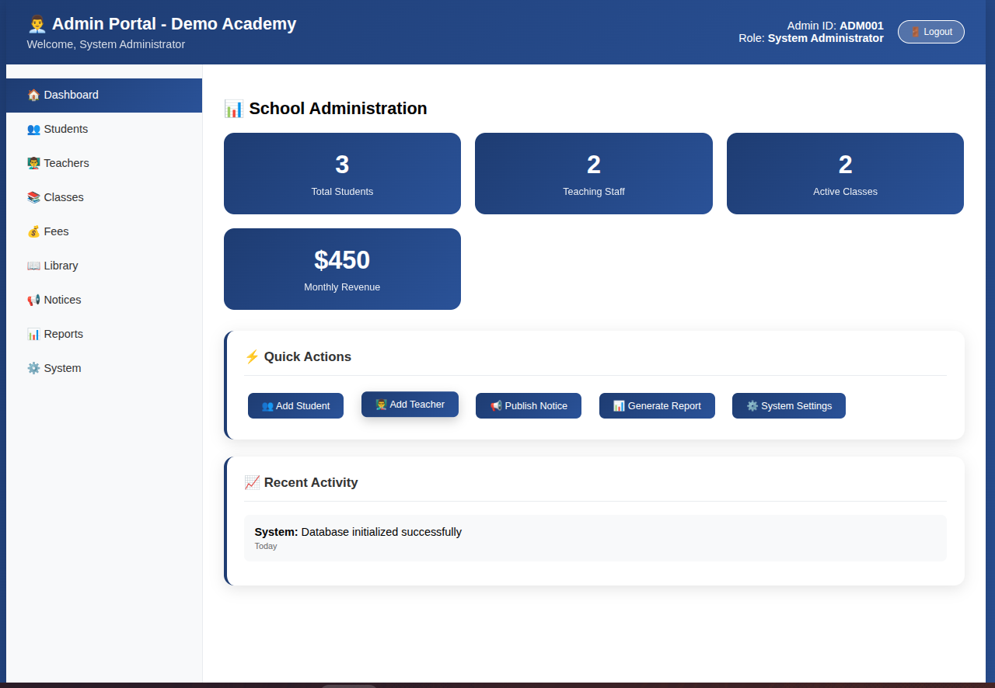

7. Web & Mobile App Availability

🌐 Web Application
- Works on all browsers
- No installation required
- Accessible anywhere with internet

📱 Mobile Application
- Installable on Android devices
- Can work as:
  - Progressive Web App (PWA)
  - APK for direct installation
- Optimized for mobile screens
Result:
Students and staff can access the system anytime, anywhere.

8. Customization & Branding
Each institution receives:
- Custom school name
- Logo integration
- School color scheme
- Custom academic structure (Forms, Departments, Courses)
Your institution’s identity is preserved and enhanced.

9. Security & Reliability
- Secure login authentication
- Role-based access control
- Protected student & staff data
- Scalable database architecture
- Ready for cloud or local hosting

10. Hosting & Deployment Options
We offer:
- Local hosting
- Cloud hosting
- cPanel hosting compatibility
- Offline-ready architecture (for low-bandwidth regions)

11. Implementation Process
1️⃣ Requirements discussion
2️⃣ Customization & branding
3️⃣ System setup & testing
4️⃣ Training & on-boarding
5️⃣ Go-live & support

12. Why Choose This Solution?
✔ Modern & user-friendly design
✔ All-in-one system
✔ Affordable compared to foreign solutions
✔ Locally adaptable
✔ Scalable for growth
✔ Web & mobile ready

13. Business Value to Institutions
- Improved academic performance tracking
- Reduced administrative workload
- Enhanced communication
- Strong digital presence
- Competitive advantage over other institutions

14. Next Steps
We invite institutions to:
- Request a live demo
- Discuss customization needs
- Pilot the system with selected classes
- Scale to full institutional use

15. About the Developer
This system is developed by a qualified software developer with strong background in:
- Web Development
- Databases & Systems Design
- Networking & Security
- Applied Mathematics & Statistics
- Machine Learning foundations
The solution is built with real institutional needs in mind, especially for African educational environments.

16. Contact & Demonstration
📧 Email: tralon2025@gmail.com
📞 Phone:+263 78 830 7612
💻 Live Demo: Available

“Empowering education through smart digital systems.”

